## Merchant Name *Summer Discovery* Implementation POC: Royce *(IM to fill)* CX POC: *[IMP to Add]*

### 

### 

| Notes Sections   *(AE to fill if they have, Implementation to be completion DRI on handoff)*   * Info on how merchant bills *(ping Austin or Vanessa for screenshot of whiteboard session).*   + For the managed part of the business, their billing schedule is quite unique and they’re open to changing it. Right now it’s:      1. 25k deposit     2. Estimated Expenses (e.g. background checks)     3. 50% of the Managed Services fee (usage based on number of students. It’s a per student, per week calculation, and this calculation could differ depending on the university)     4. Remaining amount of the Managed Service fee     5. Any Overages (from expenses incurred by staff) and remaining Expenses   1) What is the merchant temperament?   * + Eager to get started   + Open to consultative advice on their process. Open to Tabs recommending processes / ways to operate and even format contracts so that it works better in our system. They recognize that the way they’re working now is not optimal   3) What are the Tabs features that the key POC cares about?   * Automated billing and invoicing - biggest pain point. They’d love an automated way to create invoices, send invoices, automate dunning, etc. * They have relevant, unstructured data scattered that contributes to how billing is done. Being able to consolidate that and turn it into invoices automatically is big. * Connecting back to NS is important. |
| --- |

### Billing model *(Entire Section: Implementation to fill section)*

* Are there unique things about the customer creation process for this merchant?
* Information on how merchant bills
* How contract is broken up
* One off things to know about the merchant

### Contract Processing Steps *(Entire Section: Ops to fill)*

## Steps to process

* BTs are most commonly found in the *Payment Schedule* section toward the end of the contract. Each line item would be its own BT.

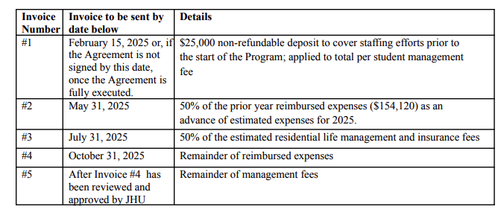

* Payment Schedule typically includes all committed payments, including estimated amounts based on prior year data.
  + These will all be BTs, even if we can’t calculate the total with the information given
    - In these cases, the BT will be $0.
* Billing Start Date: use the date listed in the Payment Schedule for each line item.
  + Always 15 days before the due date listed
    - This is because net terms will always be 15
  + Example: "Deposit Payment due February 15, 2025" → Billing Start Date = February 1, 2025
* Service Start Date: Same as Billing Start Date for each line item
* Item name: use the details column to determine the best name.
  + For shorter details, use the entire sentence
    - For example: “50% of the estimated residential life management and insurance fees”
  + For long details, shorten it using best judgement
    - For example: “"$25,000 non-refundable deposit to cover staffing efforts prior to the start of the Program; applied to total per student management fee" can be shortened to “Deposit”
* Months of Service: Default to 0 months
* Total Price: use the total amount listed per payment in the Payment Schedule.
  + Use the fee listed, no need to calculate. They will already give us the calculated amount. This will often be in parentheses.
    - Example: “50% of the prior year reimbursed expenses ($154,120)”
      * Use $154,120 as total price
  + If the amount is to-be-determined or variable based on actual expenses that haven’t occurred yet (Example: “Remainder of reimbursed expenses”) or the estimate isn’t listed, create a BT with $0.
* Frequency: set to None — Summer Discovery bills based on milestones, not recurring intervals, so there wouldn’t be a frequency.
* Net Terms: Use 15.
* Quantity: Default to 1.
* Usage/Overage Items: **Ignore**
  + Only need to follow the payment schedule, which should be flat fees only
  + There will be many BTs throughout the document, but we only want to focus on the given payment schedule.
  + Example to ignore: "Additional meals may be purchased at $25 per meal"
* [Integration Item Mapping](https://docs.google.com/spreadsheets/d/1xStVtsVeCTnAP-xR_vFhkx0K_X3x-zvEboPBI3apllE/edit?gid=0#gid=0)

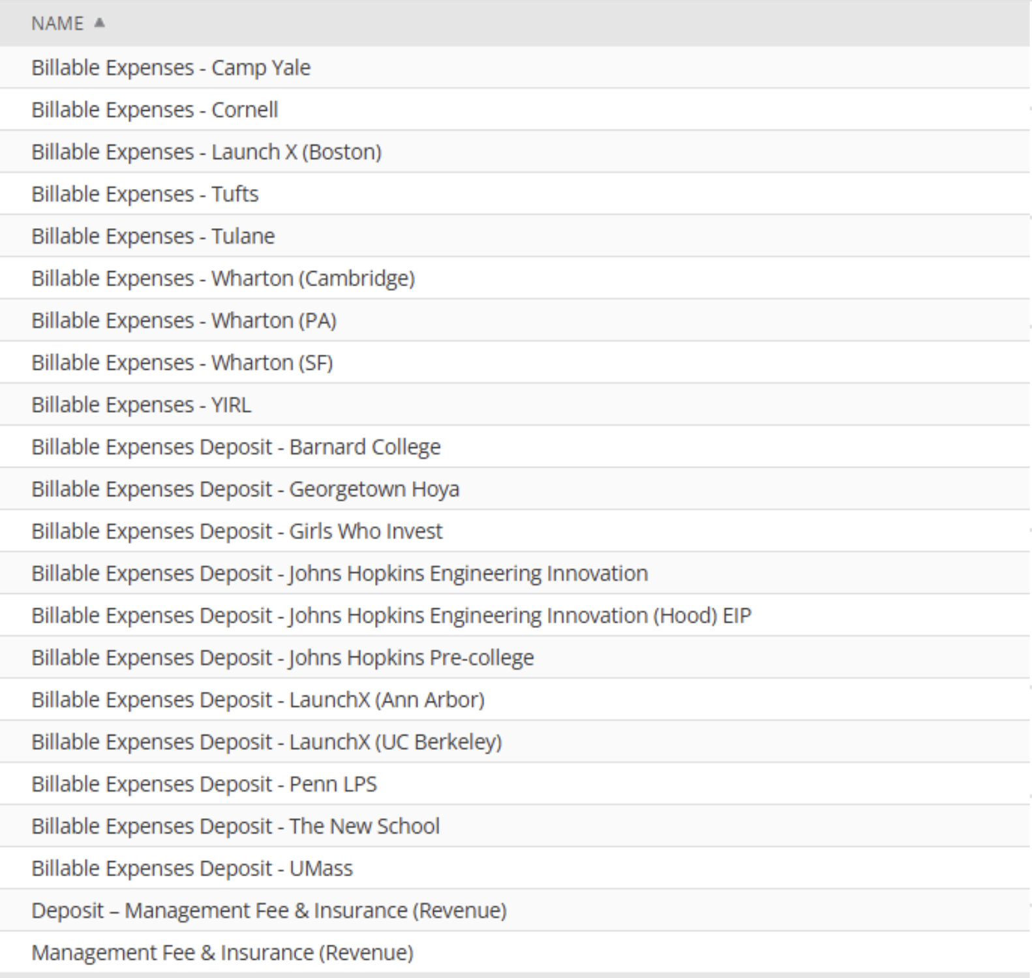

* 3 types
  + Billable Expenses
    - For any expenses, use the billable expenses integration item with the customers name at the end
    - Will use this for pretty much everything that doesn’t specifically say “fee” or “deposit” which would use the 2 below
    - If doesn’t fit the below 2 and doesn’t seem like it should be a billable expense, please leave as none and flag to the team in slack
    - There is no difference between “Billable Expenses Deposit” and “Billable Expenses.” Please just be sure to match the customer name.
  + Management Fee & Insurance
    - Anything that is a “fee”
  + Deposit - Management Fee & Insurance (Revenue)
    - Anything that is a “deposit”

1. Anything to ignore in contracts?
2. Specifics processing things the merchant has requested that may differ by contract (e.g. always back-date invoice date to final day of the month)
3. Default Service Term
   1. If None Listed, Ops Default is 1 Year
4. Default Net Payment Terms
   1. If None, Ops Default is 0
5. Default Billing Frequency
   1. If None Listed, Ops Default is Monthly
6. How do we handle taxes as a line item?
   1. If None Listed, Ops Default is every tax line item becomes a BT

### Events Processing (if necessary) *(Entire Section: Implementation/Success to fill Post-Go Live)*

* Any important information on events billing

Integration Items Processing (if necessary)  
*(Entire Section: Implementation/Success to fill Post-Go Live)*

* What are the instructions for assigning integration items?
* Example: All Statsig integrations items should be labeled as “Sales”
* Example: All “Pinata” integration items should be labeled as “Software Subscription Bundle” unless otherwise noted by Merchant

Post Processing Communications (if necessary)  
*(Entire Section: Implementation/Success to fill Post-Go Live)*

* Does the Ops Team need to notify anyone on the team re: completion of processing batches in Implementation or Active phase?
* Who needs to be notified and when?
  + Example:
    - Who: Customer Success [Azmat Aziz] needs to be notified
    - Where: Messari internal merchant channel
    - When: contracts are processed [Merchant Phase: Active]

### Customer Information *(Entire Section: Implementation/Success to fill Post-Go Live)*

* Any important information on specifics customers of this merchant
  + Special memo’s certain invoices require
  + Invoice changes due to merchant/customer relationship

### Feature Requests *(AE to fill for all requests prior to Imp handoff, Imp to fill prior to go-live/Success to fill to fill Post-Go Live)*

* FR 1
  + What is it
  + Why it's important
  + Urgency

### Merchant Calls *(AE to fill for all videos prior to Imp involvement, Imp to fill prior to go-live/Success to fill to fill Post-Go Live)*

* Intro Call: (Austin and Scott)
  + <https://us-56595.app.gong.io/call?id=7364312229228061876&account-id=8515207541940086288>
* Quick chat on price level setting and contract scoping (Austin and Scott)
  + <https://us-56595.app.gong.io/call?id=2831710205078223476&account-id=8515207541940086288>
* Contract scoping: (Austin, Vanessa, and Scott)
  + <https://us-56595.app.gong.io/call?id=7020260913517554594&account-id=8515207541940086288>
* Demo call (with Summer Discovery’s CFO and Finance Manager)
  + <https://us-56595.app.gong.io/call?id=3049351006388037880&account-id=8515207541940086288>
* Netsuite scoping call (with NetSuite overseer)
  + <https://us-56595.app.gong.io/call?id=5792724963386849071&account-id=8515207541940086288>

Austin’s Rolling Notes from the Sales Cycle:

**Key Stakeholders:**

* Scott Rosenbluth, Operations Director
  + Was told he might have to do dunning
  + No linkedin
* Fatma Abubaker - Finance Manager
* Megan Mancini - Operations Manager
* Myra Cortado - CFo
* Ashley - Netsuite overseer

**Company Info:**

* Summer Discovery runs pre-college enrichment programs at various universities
* Recently bought a program in the UK
* Two different businesses:
  + **Managed -** Managed services is where the university has an existing pre-college program, but need year round support or assistance, and they provide that to them.
  + **Branded -** owned and operate with top tier universities.

**Tools:**

* Netsuite, no invoicing software
* CRM = hubspot (still new)- not in scope
* Invoicing system = nothing!
* AP = Brex (but moving to Ramp)

NetSuite Discovery:

* Only 12-20 customers, no information tracked on the customer record, but they are created manually
  + Invoice only flow
  + Standard required fields on the invoice
    - Program
    - Class
    - Department
    - location
  + tax is not being charged
  + no multi-currency/entity

**Background/Context:**

* Onboarding new CFO. Controller is departing, to let the CFO hire her own team. Finance team turnover. Budget is locked up until the fall.
* Recently bought a program in the UK
* Two different businesses:
  + **Managed -** Managed services is where the university has an existing pre-college program, but need year round support or assistance, and they provide that to them. SOW.
    - Receive invoices. This is where we’d help.
  + **Branded -** owned and operate with top tier universities. Contracts with universities themselves.
    - Do not pay the universities. They pay the universities. No AR
* Lots of contracts. Very seasonal business. Ownership of all contracts has been fragmented in the past
* Customers typically pay ACH or Wire
  + You can configure some settings for payment methods as well.
* **Pricing Model:**
  + **Branded** - dependent on the number of rooms they can fulfill – We will NOT work with this part of their business
  + **Managed** - not dealing with housing agreements but dealing with a per student cost per week.
    - E.g. Work with Barnard and they were taking a building down to install AC, and that hurt Summer Disco revenue. So they put in minimum guarantees to get around this issue.
    - Management fees (start up fees). Might charge a fee for planning to get them ready. Then there’s a management fee (calculate per student per week, and it’s a formula they have). The remaining is bill backs - any expenses they incur to run the program, they bill for. But the baseline costs are all just on excel. No invoicing software.
      * Per student per week (if it’s 100 per student per week, for 3 weeks, then it’s 300 dollars)
    - They pay for their year, but in installments. Then the billable invoices are given separately.
* **Pain:**
  + Unorganized data management. They have 50 programs, and they don’t know which one is the most expensive to run… No synergy between cost of services and enrollment data… So they’re curious if they can build or it buy it.
    - Right now all this unstructured data is in spreadsheets
  + Not sending invoices on time!!!
    - If they’re not sending invoices on time, the university isn’t going to pay on time…. Tulane example!!
    - Biggest pain point for the business
* **Risks:**
  + Nothing is budgeted for, but they’d like to test something leading up to their fiscal year and see how it can work during the Summer.
    - Possible options:
      * Shortened contract with a renewal date when the fiscal year comes.
      * First year contract much cheaper, with a automatic increase in year 2.
* Why now?
  + Operationally, they’re doing a complete overhaul over people and systems to coincide with their acquisitions of the new programs.